11.85: a) For the same stress, the tension in wire B must be two times in wire A, and so the weight must be suspended at a distance 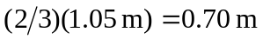from wire A..

b) The product Y A for wire B is 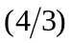 that of wire B, so for the same strain, the tension in wire B must be 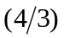 that in wire A, and the weight must be 0.45 m from wire B.

